Mod-3 Journal: Explore Modular Programming
Mary Gerdes
CS 500: Introduction to Programming
Southern New Hampshire University
February 19, 2026
Mr. Omar Hamdy

Mod 3 Journal: Explore Modular Programming

Introduction
In modern software development, modular programming is a foundational principle. Developers can create code that is more maintainable, organized, and scalable by dividing a program into smaller, self-contained units called modules. Problem-solving with this approach promotes collaboration and prepares programmers for more advanced methodologies such as object-oriented programming. Modular programming is not merely beneficial but has become essential as software systems grow in complexity. The following is an exploration of a real-world scenario in which modular programming provides an effective solution, how it can be implemented in Python, the effects of code organization, the benefits for developers, and the challenges when using this method.

Real-World Scenario
For this scenario, consider an online retail store that processes customer orders. The system needs to validate customer information, calculate order totals, apply discounts, compute sales tax, process payments, and generate order confirmations. If this were written as one block of code, the result would be difficult to read, maintain, and scale. A more structured approach would be to create modules for each distinct functionality. Each module would have its own smaller block of code.
Examples of modules inside a program, as defined functions, could include:
- validate_customer()
- calculate_subtotal()
- apply_discount()
- calculate_tax()
- process-payment()
- generate_receipt()
Each step in the ordering process is a separate responsibility reflecting a structure that follows real-world business logic. The main program would then call each function in the appropriate sequence. At a higher level, the modules could be organized into their own files, such as customer.py, pricing.py, payment.py, receipt.py, and main.py. Each module, or file in this case, could handle a specific domain of functionality, and the main program would then import the needed sections from each module.

Implementing Modular Programming using Python
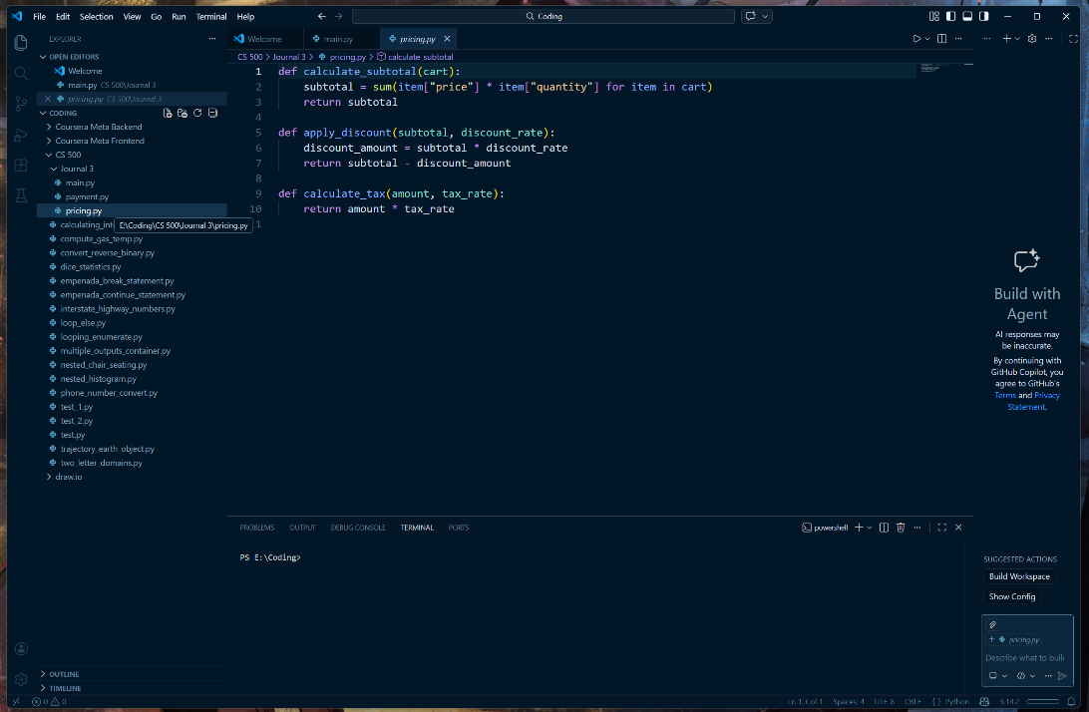
In Python, modular programming relies heavily on defined functions using the ‘def’ keyword. A function is defined using ‘def,’ followed by a function name and parentheses, and could include a return value using the ‘return’ statement (Klein, 2023a). 3Below is a simplified implementation for an online retail store scenario.

pricing.py – to calculate subtotal, discounts, and taxes.

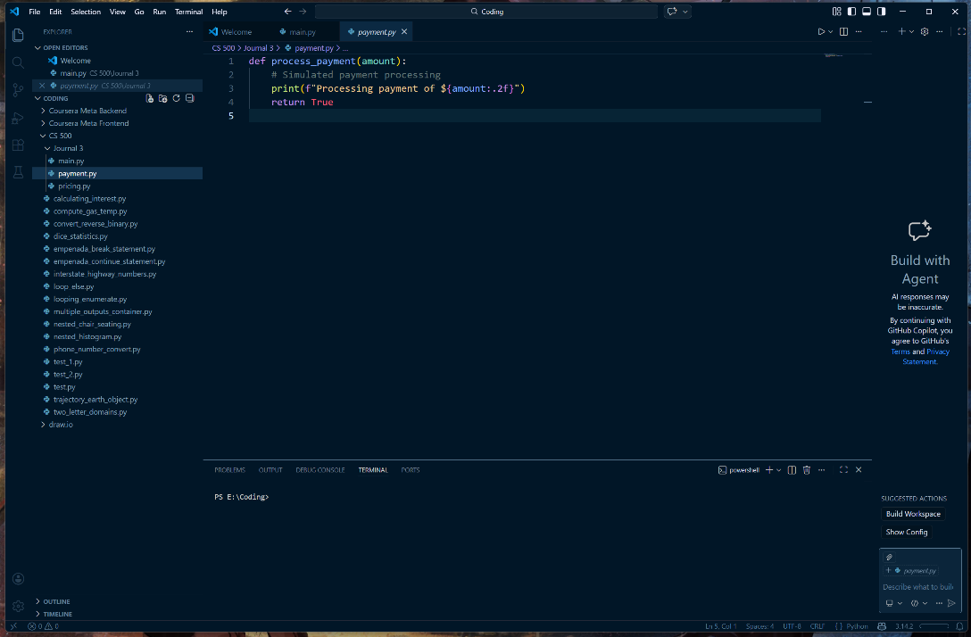

payment.py – a very simplified statement of processing a payment.

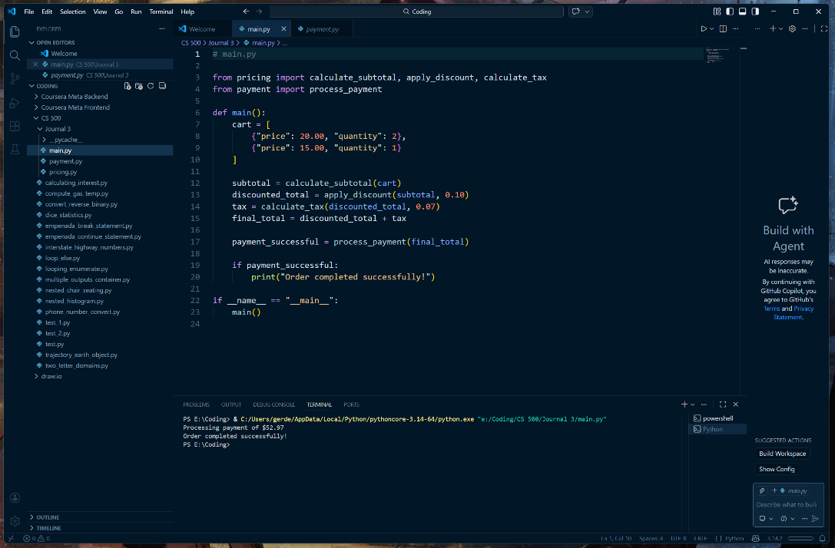

main.py – implements the two previous modules to complete an online retail transaction from a cart(as dict).

This implementation demonstrates the define, call, and return methods used in modular programming, with separate functionality in different files imported into the main program as needed (Klein, 2023b).

Improving Code Organization
In the retail example, the code organization is dramatically improved. Each function has its own responsibility. The pricing logic is separate from the payment logic, and both are distinct from the main application flow. Without modular programming, all the calculations, payment logic, and business rules would be placed in a single large script. This could create several problems, including reduced clarity where developers struggle to find specific functionality, increased duplication where similar calculations may be written multiple times, errors caused by changes that may unintentionally affect unrelated logic, and limited scalability, like trying to add a loyalty rewards program that would require modifying a large, complex block of code. Modular programming enables logical grouping, predictable structures, and easier navigation. Each file and function has a clear purpose, like real-world organizational structures, such as work departments specializing in distinct responsibilities.

Modular Programming Benefits for Developers
Developers can experience major benefits in several key areas by using modular programming. First, readability is easier since each function is divided into meaningful sections, such as ‘calculate_tax()’ and ‘process_payment(),’ which clearly describe their purpose. By simply reading the ‘main()’ function, a developer can understand the program’s workflow. Second is reusability, where functions can be reused across different projects, like using the ‘calculate_tax()’ function in another billing system. Modules can be packaged into libraries to promote shared functionality across teams, reducing redundancies. Next is testing and debugging, as each function can be tested independently using unit tests. For example, testing ‘calculate_subtotal()’ with different cart inputs or testing ‘apply_discount()’ with edge cases such as 0% to 100% and checking that the calculations are correct. Finally, with software systems evolving, maintenance will be required, tax rates change, discount policies are updated, and new payment methods are introduced. In modular design, these changes only affect the relevant function or module, making it much easier to update and maintain.

Challenges when using Modular Programming
While there are many advantages to modular programming, it also introduces potential challenges. One common issue is over-modularization, which is where a program is broken into too many small functions, or fragmentation. This can lead to excessive abstraction, making the overall logic harder to follow. Additionally, poorly managed dependencies between modules can result in tight coupling or circular imports, complicating debugging and maintenance. Modular systems require more upfront planning in their design, and using unclear naming conventions can reduce readability rather than improve it.
These challenges can be mitigated through thoughtful design and adherence to best practices. A balanced level of modularization can be achieved by grouping related functions and maintaining clear responsibilities for each module. Defining clean interfaces and organizing imports can help with dependency issues. Investing time in the initial system design, using consistent naming conventions, and documenting functions with clear descriptions will help the program remain an asset rather than a liability.

Conclusion
Modular programming is a fundamental practice that enhances the quality and sustainability of software systems. Developers can create code that is easier to read, test, reuse, and maintain by dividing complex programs into smaller, well-defined components. Functions and modules allow code to mirror real-world processes while remaining flexible and efficient, and the advantages outweigh the challenges. When applied correctly, it reduces complexity, enhances collaboration, and works as a solid foundation for advanced development practices.
References
Klein, B. (2023a, November 8). 24. Functions | Python Tutorial | python-course.eu. Python-Course.eu. https://python-course.eu/python-tutorial/functions.php
Klein, B. (2023b, November 8). Modular Programming and Modules | Python Tutorial | python-course.eu. Python-Course.eu. https://python-course.eu/python-tutorial/modules-and-modular-programming.php

References

